Key Attractions and Tourist Typologies:
Kenya is one of Africa’s leading tourism destinations because it offers diverse tourism products, including wildlife safaris, beaches, mountains, cultural heritage, adventure tourism, lakes, and urban attractions.
A tourist circuit is a geographical route linking two or more destinations and attractions that tourists visit during one trip. Tourist circuits help tour operators develop itineraries, package holidays, distribute tourism benefits across regions, and target different market segments.
Tourist typology refers to the classification of tourists according to their interests, motivations, travel behavior, budgets, or preferred experiences.
Kenya’s official tourism promotion framework identifies nine regional tourism circuits. The names and boundaries used in marketing can differ slightly from traditional safari routes. The official groupings include the Coastal, Western, Central Kenya, North Rift, South Rift, Nairobi City, Eastern, North Eastern and Southern circuits.
- Major Kenyan tourist circuits
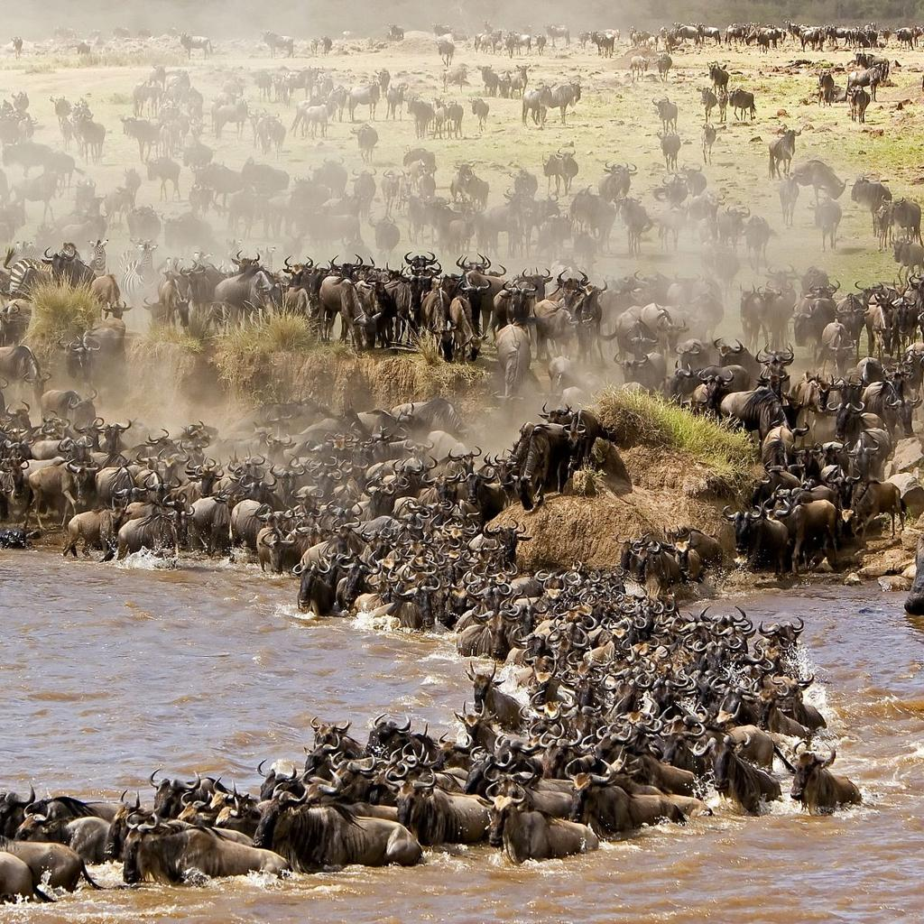
1. Southern Rift Valley and Maasai Mara Circuit
Route: Nairobi – Lake Naivasha – Hell’s Gate – Lake Nakuru – Maasai Mara
Key attractions
- Maasai Mara National Reserve: Big Five, wildebeest migration, game drives and Maasai culture.
- Lake Nakuru National Park: Rhinos, flamingos and other birdlife.
- Lake Naivasha: Boat rides, hippos and birdwatching.
- Hell’s Gate National Park: Cycling, hiking and dramatic gorges. Best-suited tourist Typologies: Wildlife enthusiasts, international safari tourists, photographers, birdwatchers, adventure tourists, honeymooners and luxury travellers.

2. Southern Kenya and Amboseli Circuit

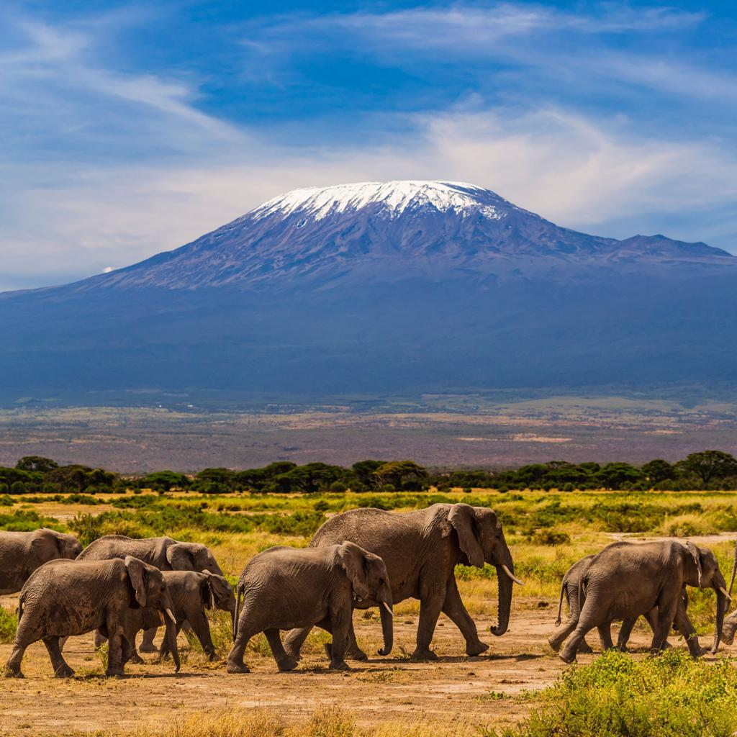2. Southern Kenya and Amboseli Circuit
Route: Nairobi – Amboseli – Tsavo West – Tsavo East – Mombasa
Key attractions
- Amboseli National Park: Large elephant herds and views of Mount Kilimanjaro.
- Tsavo West National Park: Mzima Springs, lava landscapes and wildlife.
- Tsavo East National Park: Red elephants, expansive savannah and game drives.
- Sheldrick Falls: A nature attraction for visitors prepared for a hike. Best-suited tourist Typologies: Wildlife tourists, photographers, families, nature lovers, safari enthusiasts and tourists combining wildlife with beach holidays.
3. Coastal Kenya Circuit
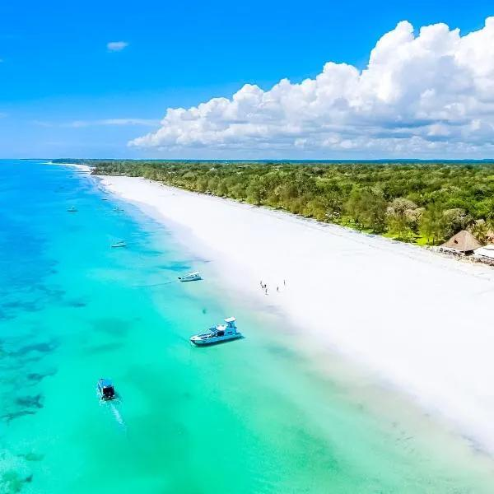
3. Coastal Kenya Circuit
Route: Mombasa – Diani – Watamu – Malindi – Kilifi – Lamu
Key attractions
- Fort Jesus: Portuguese and Swahili coastal history.
- Diani Beach: Beach relaxation, water sports, Swim with the Dolphins and resorts
- Watamu Marine National Park: Coral reefs, snorkeling and marine biodiversity.
- Malindi: Beaches, marine experiences and historic sites.
- Lamu Old Town: Swahili architecture, dhow culture and heritage.
Best-Suited Tourist Typologies: Leisure tourists, beach holidaymakers, honeymooners, families, divers, cultural heritage tourists, cruise visitors and luxury travellers.
4. Central Kenya and Mount Kenya Circuit
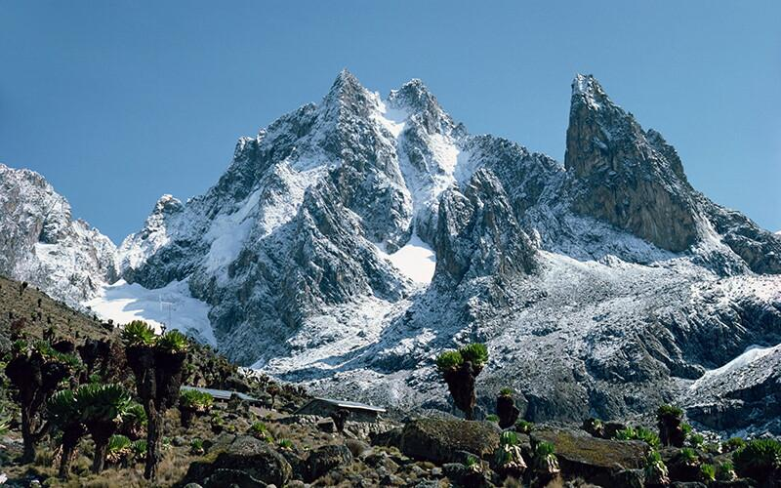4. Central Kenya and Mount Kenya Circuit
Route: Nairobi – Thika – Nyeri – Nanyuki – Meru

Key attractions
- Mount Kenya National Park: Trekking, climbing and alpine scenery.
- Ol Pejeta Conservancy: Rhino conservation, wildlife and conservation education.
- Aberdare National Park: Waterfalls, forest wildlife and mountain landscapes.
- Meru National Park: Diverse wildlife and relatively less-crowded safari experiences.
Typologies: Adventure Tourists, Mountaineers, Ecotourists, Conservation Tourists, Birdwatchers, Domestic Weekend Travellers and Educational Groups.

5. Northern Kenya Circuit
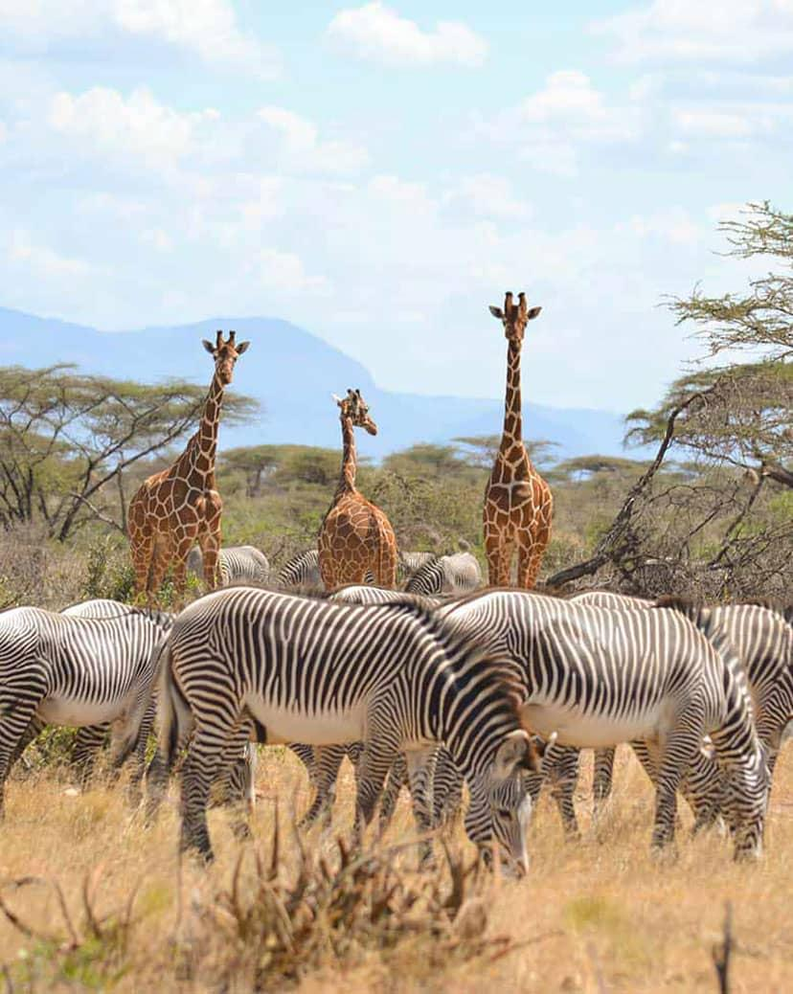
5. Northern Kenya Circuit
Route: Nanyuki – Isiolo – Samburu – Buffalo Springs – Marsabit – Lake Turkana

Key attractions
- Samburu National Reserve: Grevy’s zebra, reticulated giraffe and the Samburu Special Five.
- Buffalo Springs National Reserve: Wildlife and riverine landscapes.
- Marsabit National Park: Forested volcanic landscapes and wildlife.
- Lake Turkana: Desert scenery, cultural diversity and archaeological significance.
Best-Suited Tourist Typologies: Cultural Tourists, Adventure Travellers, Specialist Wildlife Tourists, Researchers, Anthropologists, Photographers and Off-The-Beaten-Track Travellers.

6. Western Kenya and Lake Victoria Circuit
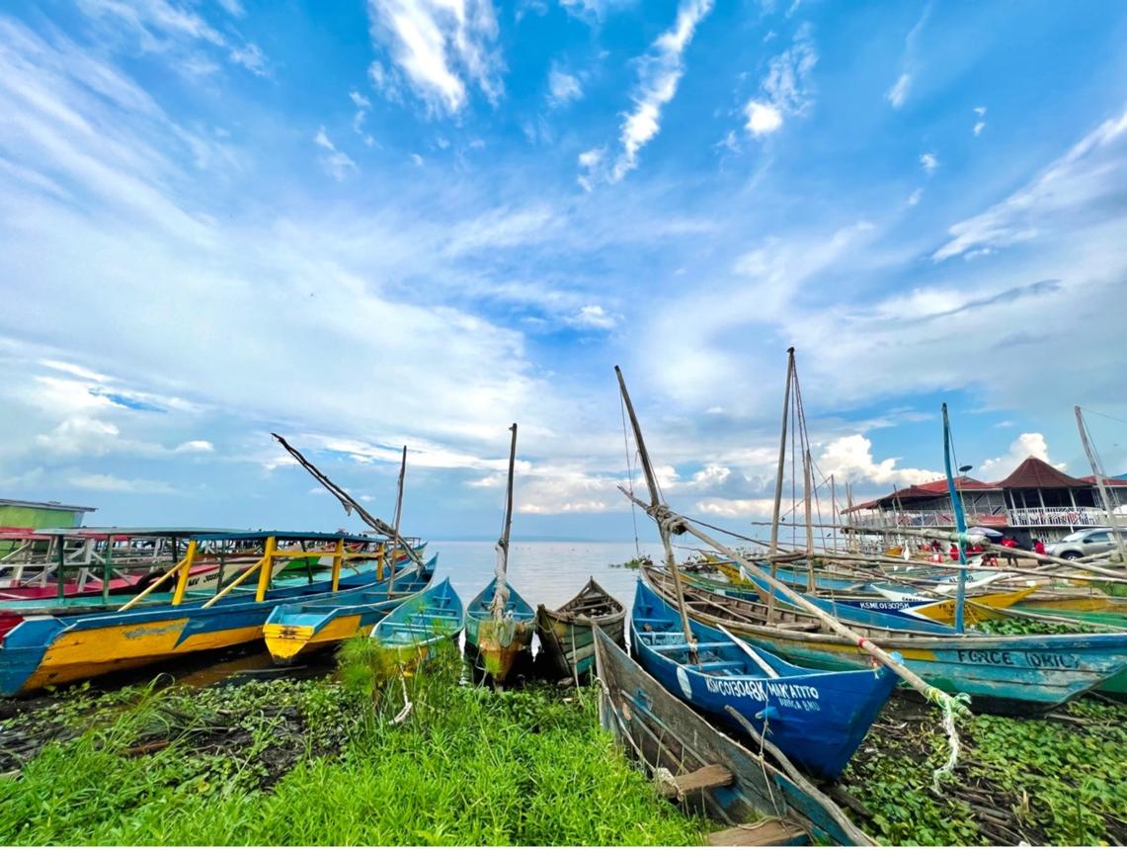
6. Western Kenya and Lake Victoria Circuit
Route: Kisumu – Kakamega – Kakamega Forest – Kitale – Saiwa Swamp

Key attractions
- Kakamega Forest: Tropical rainforest, primates and birdwatching.
- Lake Victoria: Boat trips, fishing culture and lakeside experiences.
- Kisumu Impala Sanctuary: Wildlife viewing and nature walks.
- Saiwa Swamp National Park: Sitatunga antelope and wetland birdlife.
Best-Suited Tourist Typologies: Ecotourists, Birdwatchers, Domestic Tourists, Cultural Tourists, Educational Groups, Researchers and Nature Photographers.

7. Northern Rift Valley and Lake Circuit

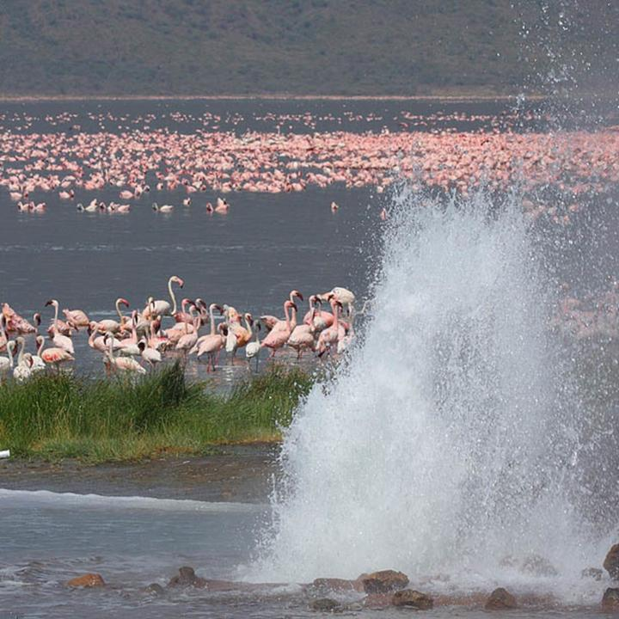7. Northern Rift Valley and Lake Circuit
Route: Nakuru – Lake Bogoria – Lake Baringo – Iten – Kerio Valley

Key attractions
- Lake Bogoria: Hot springs, geysers and flamingos when present.
- Lake Baringo: Birdwatching, boat trips and island communities.
- Kerio Valley: Escarpments, viewpoints and adventure activities.
- Iten: Distance-running culture and high-altitude training.
Best-Suited Tourist Typologies: Birdwatchers, Geo-Tourists, Adventure Tourists, Sports Tourists, Photographers, Researchers and Domestic Weekend Visitors.

8. Nairobi and Urban Tourism Circuit
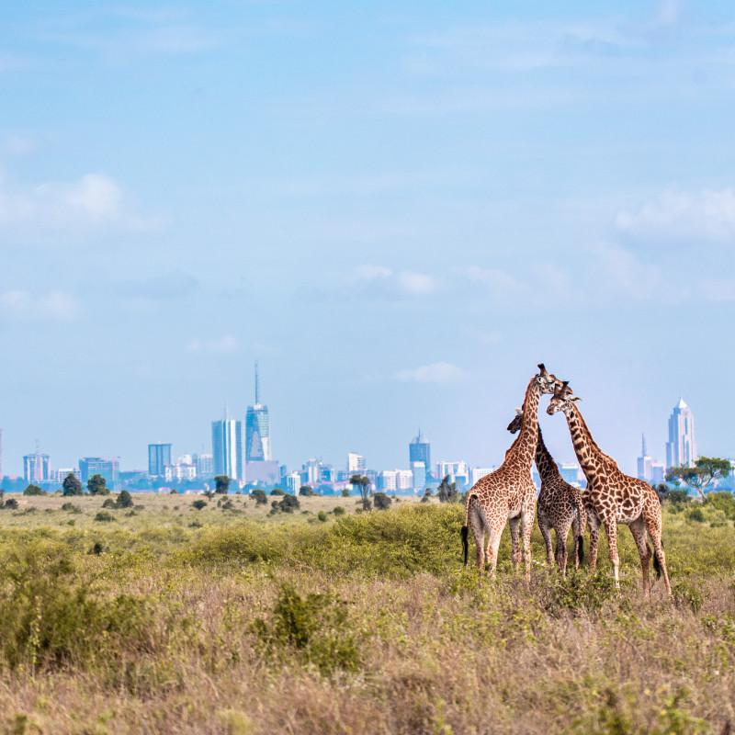
8. Nairobi and Urban Tourism Circuit
Route: Nairobi CBD – Karen – Langata – Kiambu and nearby day-trip attractions
Key attractions
- Nairobi National Park: Wildlife viewing close to a major city.
- David Sheldrick Wildlife Trust: Elephant conservation experiences, subject to visiting arrangements.
- Giraffe Centre: Giraffe conservation and environmental education.
- Karen Blixen Museum: Literary and Colonial-Era Heritage.
- Nairobi National Museum: Kenyan history, culture, art and natural history.
Best-Suited Tourist Typologies: Business Tourists, MICE Delegates (Meetings, Incentives, Conferences and Exhibitions), Transit Visitors, Educational Groups, Urban Explorers, Cultural Tourists and Short-Stay International Visitors.
9. Eastern Kenya Circuit
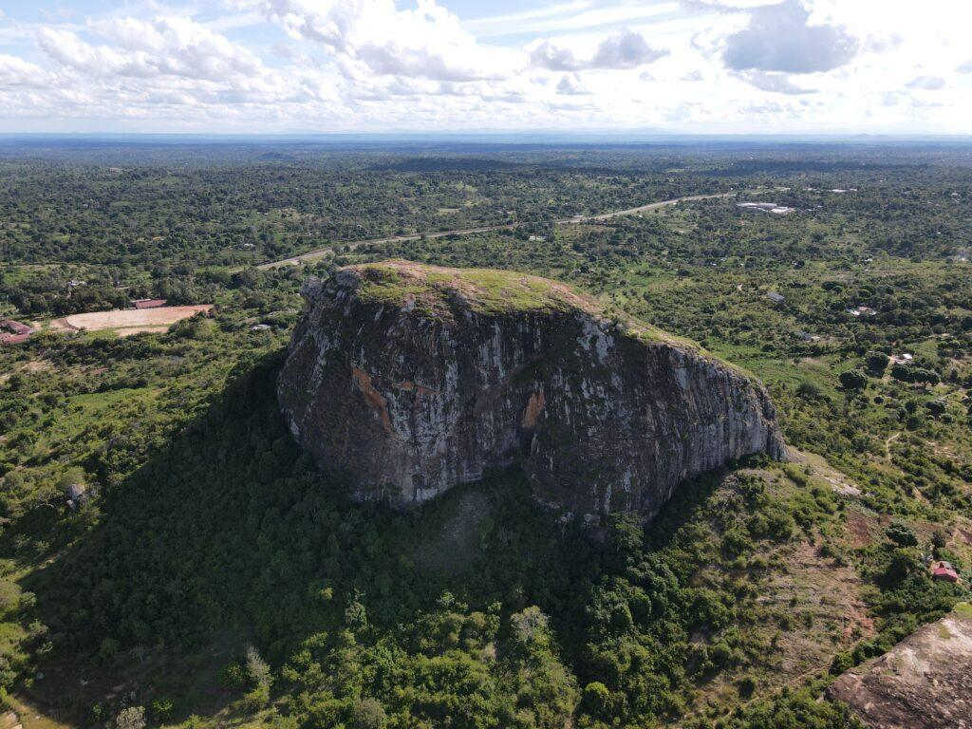
9. Eastern Kenya Circuit
Route: Makueni -Machakos – Kitui –– Embu – Tharaka-Nithi – Meru

Key attractions
- Nzambani Rock: Hiking, panoramic views and local legends.
- Mwingi National Reserve: Wilderness, wildlife and remote nature experiences.
- Meru National Park: Wildlife safaris and conservation.
- Embu and Tharaka-Nithi: Cultural heritage, agricultural experiences and scenic highlands.
Best-Suited Tourist Typologies: Domestic Tourists, Cultural Tourists, Adventure Seekers, Educational Groups, Ecotourists and Agro-Tourists.
10. North Eastern and Arid Lands Circuit
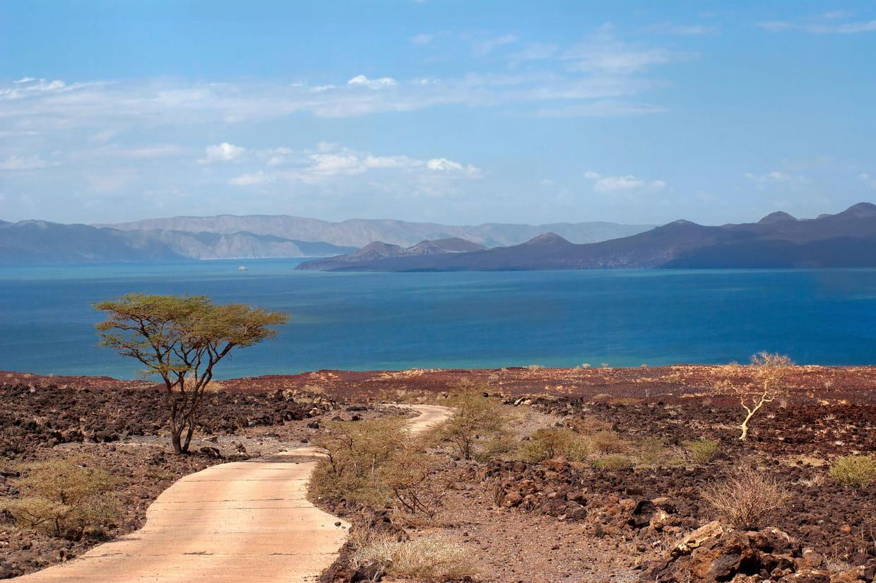10. North Eastern and Arid Lands Circuit
Illustrative Route: Garissa – Wajir – Mandera, with separate northern extensions towards Marsabit and Lake Turkana
Key attractions
- Arawale National Reserve: Arid-land wildlife and conservation.
- Sibiloi National Park: Archaeological heritage, fossils and desert landscapes.
- Garissa and surrounding areas: Somali cultural heritage, pastoral traditions and riverine landscapes.
- Northern Kenya’s desert and pastoral landscapes: Cultural encounters and specialist adventure travel, subject to access and safety conditions.
Best-Suited Tourist Typologies: Cultural Tourists, Archaeologists, Researchers, Specialist Adventure Travellers, Photographers and Experienced Off-The-Beaten-Track Tourists.
Note: Sibiloi and Lake Turkana are geographically in northern Kenya, not in Garissa or Wajir. The route above represents separate extensions rather than one continuous short circuit.

